Question 1 10 marks – 1 mark each

a Write a shell command to show the names of all files and directories in the /tmp directory

b write a shell command to copy all .c files in the ${HOME}/csse2310/trunk/a4 directory to the data subdirectory of the user’s home directory.

c Write a shell command to compile and link an executable program called "webserver” that uses pthreads and the library csse2310a4 found in/local/courses/csse2310/lib from two C files called "connections.c" and “server .c" All input and output files are in the current working directory.

d Write a shell command to save any changes from the subversion working copy (the current directory) to the SVN repository, including the log message “Fixed bug 1234”

e Write a shell command to show all lines in a file called "resolv .conf" (in the "/etc' directory) that contain the string "nameserver"

(f) Write a shell command to count the number of lines in the file "services" in the "/etc' directory that do not contain the string "tcp”.

(g) Write a shell command that finds all lines in the file "hq .c" (in the a3 subdirectory of the user's home directory) that contain the string "#define" and appends those lines to a file called "defs"in the current directory.

(h) Write a shell command that counts the number of lines in a file called "defs" (in the current directory) that contain an underscore character ('_‘) and outputs that value to standard error.

(i) Write a shell command that counts all lines in the file "vimrc" (in the "/etc" directory)that contain the string "autocmd" and saves that count value to a file called "auto . count” in the "vim" subdirectory of the /tmp directory

(j) Write a shell command that, in the user's home directory (which is not the current directory), creates a symbolic link called "altest" that points to "testa1.sh" in the"/local/courses/csse2310/bin"directory.

QUESTION 2 (6 marks - 1 mark each)

Write C declarations that declare variable "foo" to be ...

1. An array of five double precision floating point numbers initialised to the values 0, 1,3.14,2.718 and 1.618
2. A pointer to a function that can point to main ()
3. An array of characters large enough to hold the string "csse2310"
4. An unsigned integer that is 8 bits in size
5. A pointer to a single precision floating point number
6. An instance of struct Job

QUESTION 3 (4 marks - 1 mark for each address)

A machine uses 16KiB pages. Suppose a process on this machine has the following page table. All numbers are in base 10.

|  |  |
| --- | --- |
| Page Number | Frame number |
| 0 | - |
| 1 | 41 |
| 2 | 42 |
| 3 | - |
| 4 | 144 |
| 5 | 43 |
| … |  |
| 50 | 541 |
| 51 | 376 |
| 52 | 564 |
| 53 | 191 |
| … |  |
| 8191 | 1023 |
| 8192 | 971 |

For each of the following virtual addresses, what is the corresponding physical address?Write your answer in base 10. If accessing the virtual address would result in a segmentation fault, then write "SEGFAULT". If there is insufficient information in the page table (i.e. the page number is not listed) then write "UNKNOWN"

|  |  |
| --- | --- |
| Virtual Address | Physical Address |
| 7231 |  |
| 20000 |  |
| 816000 |  |
| 880600 |  |

QUESTION 4

(5 marks - 1 mark each)

Suppose a system supports process memory spaces up to 128 TiB.(1TiB = 1024 GiB.)Suppose also that it supports 40-bit physical addresses and uses a three-level page table.Pages are 16KiB in size. Page table entries are 8 bytes each.A process uses the following virtual address range (all numbers are in base 10):96 GiB starting at address 0

1. What is the number of bits in virtual addresses on this system?
2. How much memory (in KiB) would be needed to store the page table for this process?
3. If the process memory usage expanded to 256GiB (all starting at address 0), how much memory (in KiB) would now be needed to store the page table?
4. If a process used all of its virtual address space, how much memory (in GiB, to the nearest GiB) would be needed to store the page table?
5. If the original process (using 96GiB at address 0) also used 1GiB at the highest virtual addresses, then how much memory (in KiB) would be needed to store the page table?

(b)What is the maximum number of processes that could be running or runnable at any point?

(c)What is the minimum number of lines of text that this program will output when run?

(d)What is the maximum number of lines of text that this program will output when run?

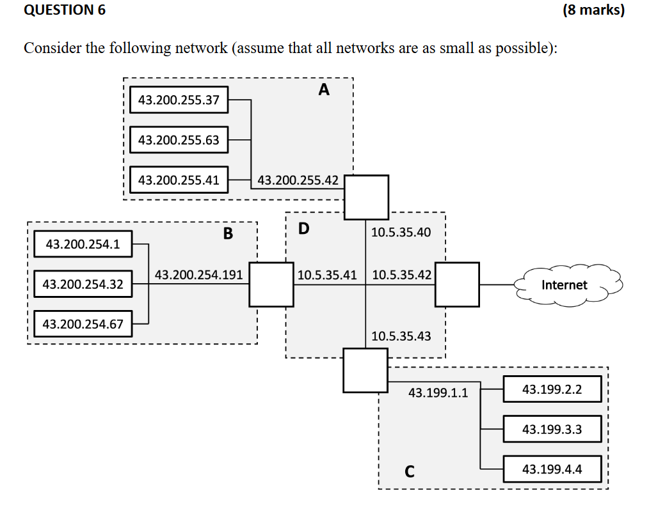

(a)

|  |  |  |  |
| --- | --- | --- | --- |
|  | Netmask | Broadcast Address | CIDR |
| A |  |  |  |
| B |  |  |  |
| C |  |  |  |
| D |  |  |  |

(b) Fill in the detail for the whole network shown above (as it would appear to the rest ofthe internet).

(2 marks)

|  |  |  |
| --- | --- | --- |
| Netmask | Broadcast Address | CIDR |
|  |  |  |

(c)

QUESTION 7

(8 marks)

A number of “unix“ file systems use inodes with 15 block pointers:

12 direct pointers,

1 single indirect pointer,

1 double indirect pointer, and

1 triple indirect pointer

Consider such a file system where blocks are 4KiB in size and block pointers are 8 bytes.

(a) What is the maximum file size supported by this file system if no indirect pointers are used? Express your answer in KiB.(1 mark)

(b) What is the maximum file size supported by this file system if the triple indirectpointer is not used? Express your answer in KiB.

(2 marks)

(c) What is the maximum file size supported in this file system? Express your answer in KiB(2 marks)

(d) What is the maximum file size if no disk blocks are used to store file data - only the block pointer space within the inode is used? Express your answer in bytes.(1 mark)

(e) Assuming the inode is cached in memory, how many blocks must be accessed to read bytes 48,001 to 2,148,000 (inclusive) from a file into memory?(2 marks)

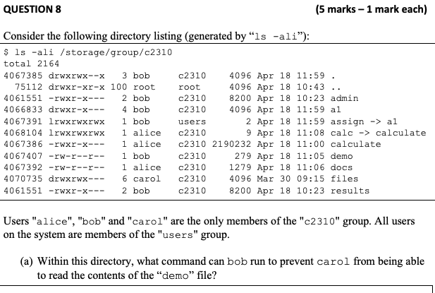

(b) Within this directory, what command can alice run to allow all users to list the contents of the calculate subdirectory?

(c) How many subdirectories does the a1 directory have?

(d) If the disk block size is 4KiB, how much disk space (in bytes) will be saved if the file admin is removed?

(e) Which users will be able to successfully run “ls -al /storage/group/c2310/assign”?

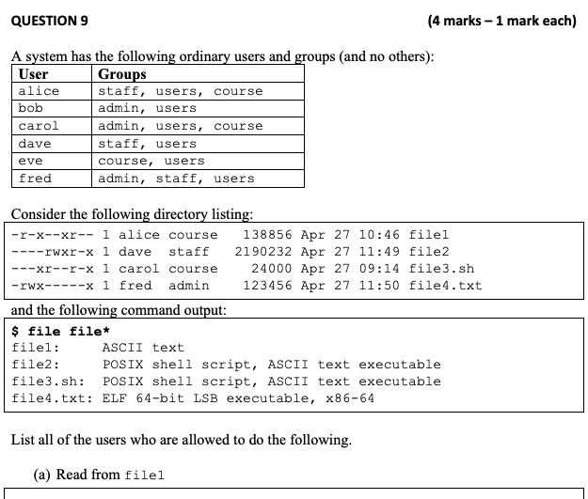

(b) Write to file2

(c) Run file3.sh

(d) Run file4.txt

Question 10 (4 marks)

